**Rose Engine Task**

**Automation System**

**RETAS**

**User Interface Design Document**

**Version 0.01**

**24 December 2023**

# User Interface Overview

The user interface needs to be simple. The menus need to allow the user to perform standardized activities from the Main Screen.

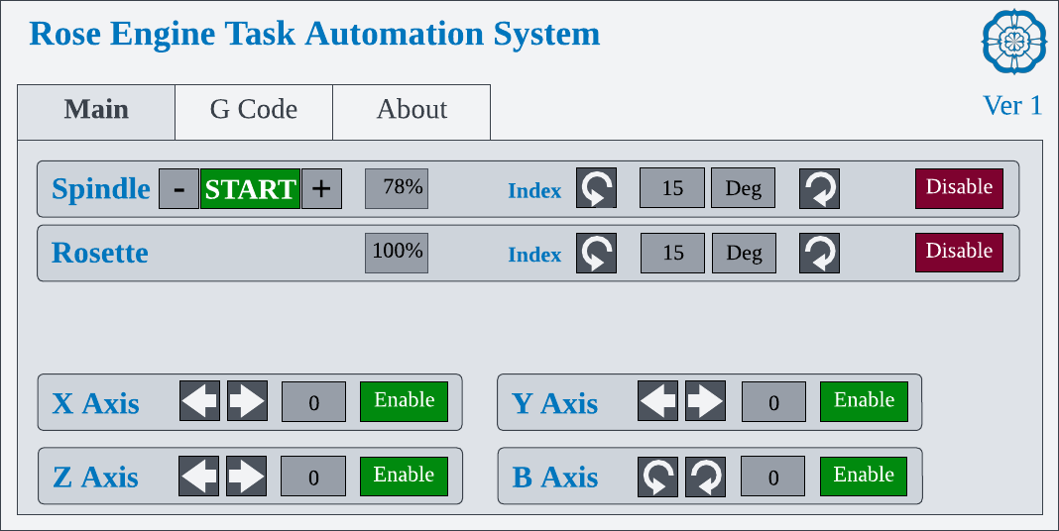

## Spindle

|  |  |  |
| --- | --- | --- |
| |  | | --- | | **START** | | Start or stop the spindle |
| |  |  |  | | --- | --- | --- | | **-** |  | **+** | | Used to decrease (-) or increase (+) the spindle speed. |
| 78% | Used to set the spindle speed (as a percentage of the max speed). |
|  | Used to index the spindle in a counterclockwise direction.  Cannot be used when the Spindle is started. |
|  | Used to index the spindle in a clockwise direction.  Cannot be used when the Spindle is started. |
| 15 | Used to set the indexing amount, based on the basis. |
| Deg | Used to set basis for the indexing amount. The options are:   * Deg(rees) * Div(isions of a circle). |
| |  | | --- | | **Disable** | | Used to disable the stepper motor (opposite of Enable) |

## Rosette(s) – C1

|  |  |
| --- | --- |
| 78% | Used to set the rosette(s) speed (as a percentage of the spindle speed). |
|  | Used to index the spindle in a counterclockwise direction.  Cannot be used when the Spindle is started. |
|  | Used to index the spindle in a clockwise direction.  Cannot be used when the Spindle is started. |
| 15 | Used to set the indexing amount, based on the basis. |
| Deg | Used to set basis for the indexing amount. The options are:   * Deg(rees) * Div(isions of a circle). |
| |  | | --- | | **Disable** | | Used to disable the stepper motor (opposite of Enable) |

## X Axis

|  |  |
| --- | --- |
|  | Used to move the X axis towards the operator (negative direction) |
|  | Used to move the X axis away from the operator (positive direction) |
| 0 | Distance to move |
| |  | | --- | | **Enable** | | Used to enable the stepper motor (opposite of Disable) |

This axis of movement is foreseen as needed for

* Movement of the tool when held in a cross slide.
* Movement of the tool when held in a linear slide (such as when cutting threads).
* Movement of the tool when held in a curvilinear slide.

## Y Axis

|  |  |
| --- | --- |
|  | Used to move the Y axis up, away from the lathe bed (negative direction) |
|  | Used to move the Y axis down, towards the lathe bed (positive direction) |
| 0 | Distance to move |
| |  | | --- | | **Enable** | | Used to enable the stepper motor (opposite of Disable) |

This axis of movement is foreseen as needed for

* Movement of an object held in a dome chuck or a pencil chuck.

## Z Axis

|  |  |
| --- | --- |
|  | Used to move the Z axis to the left, towards the headstock (negative direction) |
|  | Used to move the Z axis to the right, away from the headstock (positive direction) |
| 0 | Distance to move |
| |  | | --- | | **Enable** | | Used to enable the stepper motor (opposite of Disable) |

This axis of movement is foreseen as needed for

* Movement of the tool when held in a cross slide.

## B Axis

|  |  |
| --- | --- |
|  | Used to move the Z axis to the left, towards the headstock (negative direction) |
|  | Used to move the Z axis to the right, away from the headstock (positive direction) |
| 0 | Distance to move |
| |  | | --- | | **Enable** | | Used to enable the stepper motor (opposite of Disable) |

This axis of movement is foreseen as needed for

* *Movement of an object held in a dome chuck or a pencil chuck (rotation).*

## A Axis

Not accommodating this axis of movement at this time.

## C Axis

Not accommodating this axis of movement at this time.

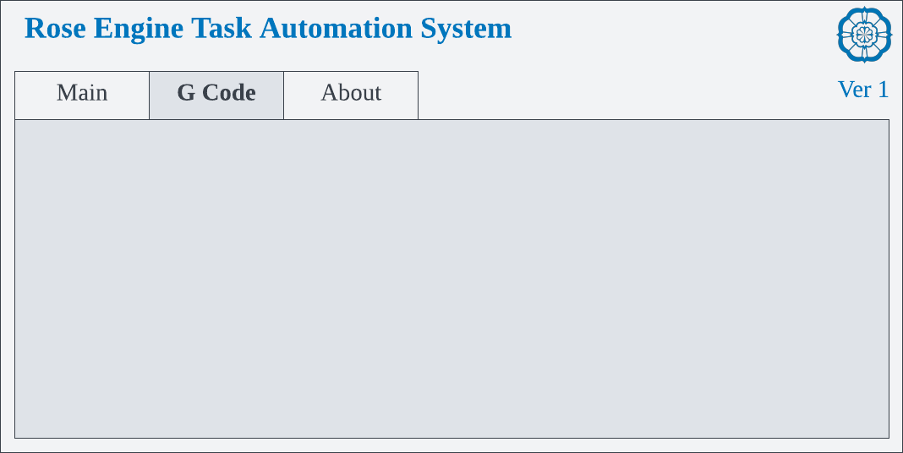

This page is used to load and execute G Code text files.

This page tells about the system.

**Notes / Questions:**

1. A diagram of a graph

   Description automatically generatedAxes reference:
2. Do we want to be able to disable any axis if the machine does not support it?
   1. That may make it more usable for users who only want simple functionality.
   2. It would require more skills for configuring this by the users.
   3. Maybe it is better to just deliver the system with everything, and let the users only use what they want.